Title Appear Here Font: Times New Roman, size 10, bold, adjusted to left margin.

**A. Kowalski**1, P.J. Barnes2, B.C. Nowak3

(1) University of Warsaw, Faculty of Physics, Institute of Geophysics, (IGFUW), Pasteura 5, 02-093, Warsaw, Poland

(2) Institute of Heath, Mitigation Department, Lambert street 5, Barnsbury, London, N1 1, England, United Kingdom

(3) Instructions: Names in size 9, Affiliations in size 8 both in font Times New Roman, italic; give presenting author in bold, give contact e-mail to a single corresponding author

Corresponding author: bcnowak@emu.edu.pl

Introduction

The abstracts are restricted to 4 pages (shorter abstracts will not be accepted). The text font is Times New Roman, font size is 9. The subsections titles (e.g. **Introduction**) are fixed and must be given in bold. Text lines adjust between left and right margins. Refer to literature in numbers only, e.g. [1], [2], and [3].

Our goal is to provide at ELC2025 a forum for the presentation of knowledge and experiences that will result in fruitful discussions, exchange of ideas and networking with other participants. We encourage young scientists to take part in this event. It is a great opportunity to meet experts in lidar-related topics and gain knowledge and opportunities for future work. Quality abstracts and presentations are part of the effort.

Methodology

In the Methodology section the methods and techniques need to be described in enough detail for the reader to understand the limitations of the method. The mathematical formula need to be given in form of equations, numbered on the right margin. An example is given below (Eq. 1).

$α≥β$ (1)

where $α$ is the goal, and $β$ is the result. Well written methodology, instrumentation (photos are welcome) and measurement scenarios descriptions will help in discussions, exchange of ideas and networking with other participants.

Results and Discussion

Please make sure that the figures you provide are of high quality, mind the size of font on the figure labels to be well visible. The figures and tables need to be referred to and well described in the text. This need to be followed by discussion of the results in context of other research. Please see an example in figure below (Fig. 1) were we show the histograms of the wavelength-dependent aerosol optical depth (AOD) values for individual layers divided into the biomass-burning aerosol types according to the area of origin (WE: Western Europe, EE: Eastern Europe, NA: North America, and IP: Iberian Peninsula). The study was based on the PollyXT-UWA lidar measurements in Warsaw in 2013-2022 (more info in [3]).

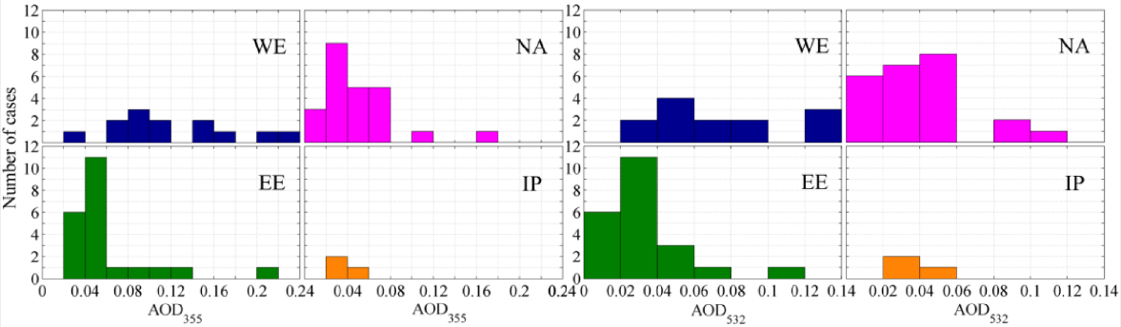

**Figure 1**. Figure caption at the bottom, centered. Font: Times new Roman, size 8. Figure size should fit in between 12 cm x 12 cm and cannot exceed the text margins.(after [3])

Please read below the Copilot explanation why it is important to give clear, high-quality figures in research papers (do not forget to cite online info sources as follows: *https://copilot.microsoft.com; last access, 20/02/2025*):

* Enhanced Understanding: Well-designed figures make complex data and concepts more understandable, helping readers quickly grasp the core findings and implications of the research.
* Visual Appeal: High-quality figures make the paper visually appealing and engaging, encouraging readers to explore the content in detail.
* Efficient Communication: Figures can convey information more efficiently than text alone. They provide a visual summary of key points, making it easier for readers to absorb and retain the information.
* Credibility: Clear, professional figures enhance the credibility of the research. They show that the authors have taken care to present their work accurately and professionally.
* Accessibility: High-quality figures can make the research more accessible to a wider audience, including those who may have difficulty understanding complex text but can quickly interpret visual information.
* Impact: Compelling figures can highlight the significance of the research findings, making them stand out in the field and potentially attracting more attention from other researchers, reviewers, and funding bodies.

Moreover, it should be quite obvious that also clear, high-quality tables in research papers are just as important as figures. Especially, in terms of data organization:

* Organized Data: Tables are excellent for presenting data in a structured and organized manner, making it easy for readers to find and compare specific values.

By focusing on clear, high-quality figures and tables, researchers can effectively communicate their work and data, making it more impactful and easier to understand for a broad audience. An example of Table is given below (Table 1), please note that data uncertainties are of high interest to community.

At last but not least, please do make sure that you use English check for your contribution for both the abstract but also for the presentation. Large fonts, high quality figures used in presentations and posters are really making easier to get your research findings across the community.

**Table 1**. Table caption on top, centered. Font: Times new Roman, size 8. Inside Table, use font: Times new Roman, size 9, descriptive lines: bold.

|  |  |  |  |
| --- | --- | --- | --- |
| **Time UTC** | **β 532 nm**  **[Mm-1 sr-1]** | **α 532 nm**  **[x10-4 m-1]** | **δ 532 nm**  **[%]** |
| 07:00 | 1.5 ± 0.5 | 0.8 ± 0.2 | 10 ± 4 |
| 08:00 | 2.0 ± 0.5 | 0.8 ± 0.2 | 12 ± 4 |
| 09:00 | 1.1 ± 0.3 | 1.5 ± 0.3 | 14 ± 2 |
| 10:00 | 3.8 ± 0.4 | 1.5 ± 0.1 | 20 ± 3 |
| 11:00 | 2.0 ± 0.5 | 0.8 ± 0.2 | 12 ± 4 |
| 12:00 | 1.1 ± 0.3 | 1.5 ± 0.3 | 14 ± 2 |
| 13:00 | 3.8 ± 0.4 | 1.5 ± 0.1 | 20 ± 3 |
| 14:00 | 2.0 ± 0.5 | 0.8 ± 0.2 | 12 ± 4 |

Conclusions

We hope that this template is useful to you. We look forward to see your research work evaluated and highly judged be the reviewers. Remember that the book of abstracts will be published and accessible online. We thank you for your cooperation. Fingers crossed. And hopefully see you soon ☺.

Acknowledgements

This work was financed by …. (please specify the funding source / give a grant number).

In this work we used data form…. (please specify the data source / give a grant number).

References

[1] Kowalski, A. and Nowak, B.C.: *The full title of the 2-authors research paper*, Journal, 169, 162–174, 2024.

[2] Rossi, A., Smith, G., and Wagner F.J.: *The full tiltle for 3-authors research paper*, Journal, 169, 162–174, doi:10.2788/914, 2024.

[3] Janicka, L. et al.: *Long term observations of biomass burning aerosol over Warsaw by means of multiwavelength lidar*, Opt. Express, 31, 33150-33174, doi.org/10.1364/OE.496794, 2023.